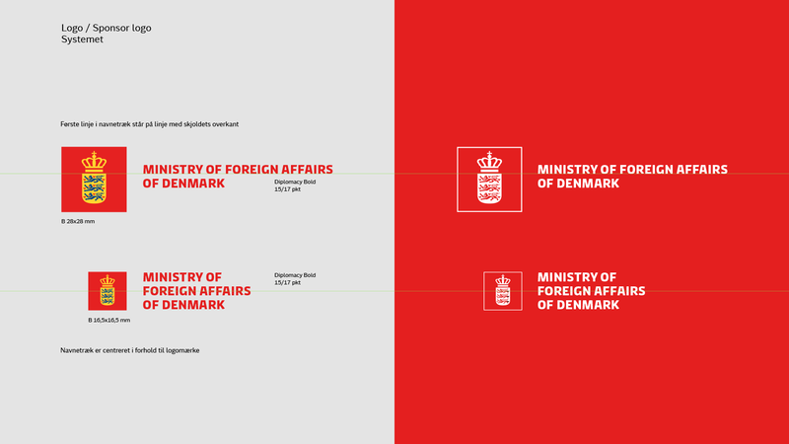

**The Danish Embassy in Vietnam is looking for a full time locally employed Driver**

The Danish Embassy is inviting qualified candidates The Embassy is inviting qualified candidates to apply for a vacant position as driver at the Embassy of Denmark in Hanoi.

**Main tasks and responsibilities**

* Driver for embassy staff in Hanoi and surrounding provinces
* Maintain and keep the vehicle clean, responsible for the car log-book
* Delivering mail to VN authorities, other embassies and international organizations
* Assist with delegation visits: supporting with logistics, coordinating with external parties, e.g. other transportation providers, protocol and police
* Assisting with Embassy events
* Assist in administrative work, e.g., scan, copy documents, manning the reception area if the receptionist is away, escort maintenance workers around the embassy premises, check and ensure all printers / scanners / photocopiers / equipment are working properly, help with minor IT task such as preparing the equipment for video conference meetings
* Assisting posted staff with car/motorbike registration, driving licenses and duty free quota books
* Ad hoc tasks from all colleagues
* Back-up for Ambassador’s driver

**Required qualifications**

* Hold a valid B2 driving license issued by the Vietnamese Authority
* Several years driving experience (experience from international organizations/embassies would be an advantage)
* Good driving skills, familiar and compliant with the road traffic laws
* Good communication skills, high sense of responsibility in work, honest, flexible and open
* Good English skill required
* IT skills an asset

**Organizational placement:**

* The position is located at the Danish Embassy in Hanoi, Vietnam

**Salary and terms of employment:**

* Competitive salary based on previous experience
* Expect some travel activity, mostly within Vietnam
* Working hours: 40 hours per week
* It is a condition of employment that you can be security cleared and that you can maintain your security clearance throughout the employment period

**How to apply:**

Please send motivated application, CV, recommendations and 2-3 references in English to ‘Embassy of Denmark’ at email: [hanamb@um.dk](mailto:hanamb@um.dk) clearly marked “Your name – Driver application” in the subject no later than **27/12/2024**. Sending CV alone is not regarded as an application.

For questions, please contact Mrs. Le Thi Thanh Hai at +84 24 3935 2938 during office hours.

Applications are welcome from all qualified persons regardless of race, sex, religion, age or disability.

Only shortlisted candidates will be contacted.